A Labour Market Capability Strategy
- discussion paper

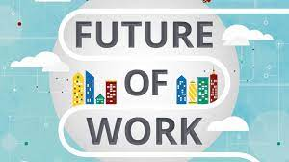

March 2022

Produced by Dr. Jude Walker
FutureWorking
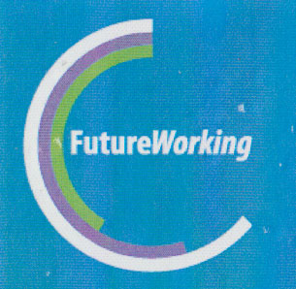

Table of Contents

Introduction 1
Background 1
The global picture 3
Labour economics 4
The development of new models of thinking 7
The Sustainable Development Goals (SDGs) 7
The structural changes in labour markets 10
Industry 4.0 12
The impact of new technologies 15
The future of work 17
Education 4.0 20
The Australian picture 26
COVID-19 28
Other issues affecting the Federal Government 29
The G21 Regional picture 31
What do we need to think about for the future? 32
What are the capabilities that will be important in the future? 32
The Cogitaire 5 Model 34
What can we do locally? 37
Conclusion 38

Table of charts
Chart 1 - Major issues facing Australia, Lowy Institute, 2016 28
Chart 2 - Coalition 'report card' - Lowy Institute, 2021 28
Chart 3 - Analysis of adult problem solving, adaptation skills and exposure to labour market 35

Table of tables
Table 1 - Comparison between the three schools of thought in labour economics 6
Table 2 - Economic response to COVID-19 29

Table of figures
Figure 1 - Quote about labour markets - Gareth Hutchens 4
Figure 2 - UN Sustainable Development Goals 8
Figure 3 - Australia's progress towards achievement of the SDGs, 2019 10
Figure 4 - Breakdown of employment patterns, Grattan Institute 12
Figure 5 - Industrial revolutions 14
Figure 7 - From a post on LinkedIn 16
Figure 8 - Geelong data for jobs vulnerability 1 – RAI 18
Figure 9 - Geelong data for jobs vulnerability 2 – RAI 18
Figure 10 - WEF estimates of occupations which are likely to grow and those likely to decrease 19
Figure 11 - WEF Quality Education Strategic Intelligence map 22

Introduction

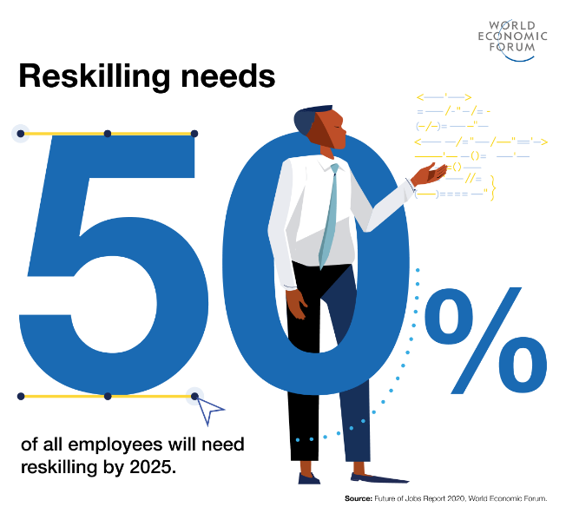

https://www.weforum.org/agenda/2020/10/what-to-expect-from-the-jobs-reset-summit/

Many regions are currently grappling with a number of complex, multi-dimensional issues relating to local economies and the future of work, particularly in times of potential post-pandemic, current global unrest, and uncertain labour market futures.

This paper is designed to make leaders, other individuals and organisations in the regional areas aware of the economic opportunities and challenges facing regions as a result of global labour market restructuring, the introduction of new technologies and the COVID-19 pandemic, particularly how National and Local Governments have responded and the impact of those responses on regional labour markets.

In building this understanding, it is important to focus, not just on an individual Region, but rather on the interconnectedness of global, national, state, other regions with local Regional labour markets. This is because, in these days of global accessibility, no labour market operates in isolation.

Background
It is impossible to create a “one-size-fits-all” process for understanding and implementing labour market policy and systems, especially in a country as large and diverse as Australia. Firstly, it is necessary to develop both a geographic and an economic understanding of what a labour market is and how labour markets operate.
With regard to a geographic understanding, we need to break down our picture of the country into more manageable bites; in this case, these are regions.
According to the Regional Australia Institute, aside from capital cities, there are four distinct types of regions:
- “Regional Cities, which have populations of over 50,000 persons. They have diverse economies and the chance to use their size and diversity to shape their own future.
- Connected Lifestyle Regions do not have city population size but are close to our major metropolitan regions. They will be influenced by their connection with these cities.
- Industry and Service Hubs are regional centres with between 15,000 – 50,000 residents, located further from major metropolitan areas. Their performance is linked to industry outcomes, but their population size means they could be resilient to change.
- Heartland Regions are smaller regional areas that are not close to other major metropolitan or Regional Cities. Industry trends and local ingenuity will shape their future.” (p. 3)
Although these definitions are focused on those parts of Australia which are not part of capital cities, the labour markets in our capitals must also be considered in smaller local areas rather than as one homogenous economic whole. Local Government Areas (LGAs) are usually the basis on which these are considered, although other factors such as educational catchments and the areas of focus for differing industry and community groups may also form the basis for trying to understand the local labour market and its catchment geographic area.
Understanding the economic aspects of labour markets relies on the schools of thought discussed in the later section on Labour Economics.

The global picture

In 2020, the global workforce lost an equivalent of 255 million full-time jobs, an estimated $3.7 trillion in wages and 4.4% of global GDP, a staggering toll on lives and livelihoods. While vaccine rollout has begun and the growth outlook is predicted to improve, an even socio-economic recovery is far from certain. The choices made by policy-makers, business leaders, workers and learners today will shape societies for years to come. At this critical crossroads, leaders must consciously, proactively and urgently lay the foundations of a new social contract, rebuilding our economies so they provide opportunity for all.

World Economic Forum – Jobs Reset Summit 2021

Over the past ten to twenty years, we have seen some significant changes in the global economic environment. These revolve mainly around new ways of thinking about a range of big issues, the impact of new technologies and their effect on current and future jobs, the structural changes to the way we work and finally the pandemic.

Labour economics
Solow once said: "The labour market is a social as well as an economic institution and the interaction between human beings cannot be interpreted in the same way as the supply and demand for dead fish."

Figure 1 - Quote about labour markets - Gareth Hutchens

Labour economics is one of the most important disciplines in Australia today. Such high importance reflects the fact that it focuses on some of the key issues facing contemporary Australians: hours of work, the distribution of income, the role of unions, the future of workplace relations, and the role of government in policy formulation, to name but a few. Indeed, there are very few issues of concern to the Australian public which do not in some respect involve the labour market and labour economists. This was recognised in a Federal Government inquiry into labour market policy which stated that “the labour market plays a critical role in distributing income, governing life chances and defining personal identity”

For many years Governments in many countries and across many philosophical points of view have been driven by an overwhelming focus on the neoclassical labour economics model, more commonly known as economic rationalism, which posits that a labour market is driven by a simple supply and demand approach in which labour shortages in an industry will drive up wages, followed by an increase in employment interest in those jobs by jobseekers and a concurrent recruitment rise. This school of thought erroneously treats labour markets as being the same as goods and services markets which, when demand goes up, can respond by increasing production and therefore increasing supply. In a labour market, new jobseekers cannot simply be manufactured to meet industry labour shortages. This is further exacerbated if additional education/training is needed for the job in question, thereby resulting in a further lag before skill shortage jobs can be filled despite potentially higher wages. This means that the economic rationalist model is only one part of the equation.

The other two schools of thought which are part of the labour economics discipline are the radical school which focuses on the uneven relationships of power between employers and employees, and the institutional school which subscribes to the opinion that, because they involve humans, labour markets are often chaotic and are affected by more than just economic factors.

This school of thought also believes that the individuals who make up the labour force (comprised of those who are working as well as those who are looking for work) often do not make rational, considered decisions based on the salary being offered. Other factors such as the availability of childcare or proximity to family members, etc. will influence decision making about work.

Due to this, the institutionalists use a multi-disciplinary (very collectivist) approach as opposed to the uni-disciplinary (very individualist) approach which is how the neoclassical, or economic rationalist, considers labour market issues. The multi-disciplinary approach used by the institutional school practitioners takes the view that, to understand and address issues impacting positively or negatively on a labour market, regional leaders and other influential individuals and organisations need to consider not only economic factors, but also geography, sociology, psychology and politics, just to name a few.

In trying to understand and address labour market problems, the institutionalists are looking into the future to determine how all of the factors in the labour market can adapt to the major problems affecting people and organisations in the community.
In doing this, they stated that “Short-term urgencies should not eclipse long-term goals”.

The following table shows the characteristics of each school of thought in the labour economics discipline.

School | Broad objectives | Key concepts | Main methodology | Ideological stance | Policy prescriptions
Neoclassical | Integration of labour economics into mainstream neoclassical economics | Work/ leisure choice; human capital theory; marginal productivity theory of demand; labour market competition | Mathematical modelling and econometric analysis | Right of centre | Need to reduce market imperfections and let free market work; decentralised bargaining; supply-side focus
Institutional | Integration of labour market institutions into analysis | Internal labour markets; segmented labour markets | Multidisciplinary analysis | Centre | Creation of more jobs; wages policy
Radical | Introduction of power into labour economics | Distinction between labour power and labour | Application of Marxian concepts | Left of centre | Transform capitalism into socialism
Table 1 - Comparison between the three schools of thought in labour economics

Whilst the Australian Government, as well as many other western governments, are still very focused on the neoclassical, or economic rationalist model, other stakeholders are intuitively moving much more towards the institutional model as they grapple with the global changes in labour markets due to restructuring and the impact of new technologies, as well as the COVID-19 pandemic.
If the G21 Regional Skills Strategy is to be effective, then regional leaders and policy makers must understand the wider range of factors impacting our potential future and the different types of economic, political and social disciplines which can contribute to our understanding of our labour market. This will enable us to identify and implement relevant and powerful strategies which can ensure that the G21 Region and its labour market meet the needs of all residents and visitors and contribute to a vibrant and inclusive economy.

The development of new models of thinking

The Sustainable Development Goals (SDGs)

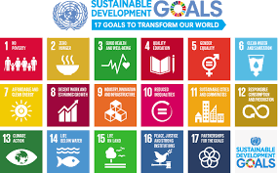

“The Sustainable Development Goals (SDGs) were born at the United Nations Conference on Sustainable Development in Rio de Janeiro in 2012. ... The SDGs replace the Millennium Development Goals (MDGs), which started a global effort in 2000 to tackle the indignity of poverty.
Figure 2 - UN Sustainable Development Goals

The World Economic Forum has identified three major pieces of work which are critically important, and which they classify as “pressing long-term challenges: achieving the United Nations Sustainable Development Goals (SDGs) by 2030; delivering on the Paris climate agreement over the next 30 years; and reforming our global economic system to make it fit for the next 50 years and beyond.”

Much of the work in gaining engagement by countries around the world with the SDGs is now being shared between the United Nations and the Organisation for Economic Cooperation and Development (OECD). Each country which signs up to the SDGs is required to produce an annual report on their results.
In 2019, the UN highlighted concerns with the slow progress that has been made towards achieving the aims of the agenda and drew attention to the need for urgent action to achieve the SDG goals over the next decade. In Australia, mixed results have been achieved in the areas of economy, education and health, and fairly poor results with regard to the “reduce inequality” goal (see graphic on the f0llowing page).

In its 2020 progress report on Australia’s achievements against the SDGs, the Monash Sustainable Development Institute notes that:
“Australia is performing well in health and education, but is failing to reduce CO2 emissions, waste and environmental degradation, and to address cost of living pressures and economic inequality. Of the 56 indicators examined in this report, only 12 are assessed as on track to meet the 2030 targets. 23 indicators are assessed as off track, 11 are classified as breakthrough needed and 10 need improvement. The report also shows COVID-19 has exacerbated trends — including higher levels of unemployment, poverty and psychological distress — that were emerging before COVID-19, and that could fracture Australian society.”
If Australia is to make a sustainable recovery from the pandemic and attempt to deal with future global shocks, then the report identifies three strategies which will be critical. These are “taking a long-term perspective; increasing the use of data and evidence; and incorporating a diversity of views, with an emphasis on building novel partnerships”.
Organisations, including municipal councils, are now also reporting on their contributions towards achievement of the SDGs and individuals who are interested in supporting the SDGs can do so through the Global Citizens’ Movement.

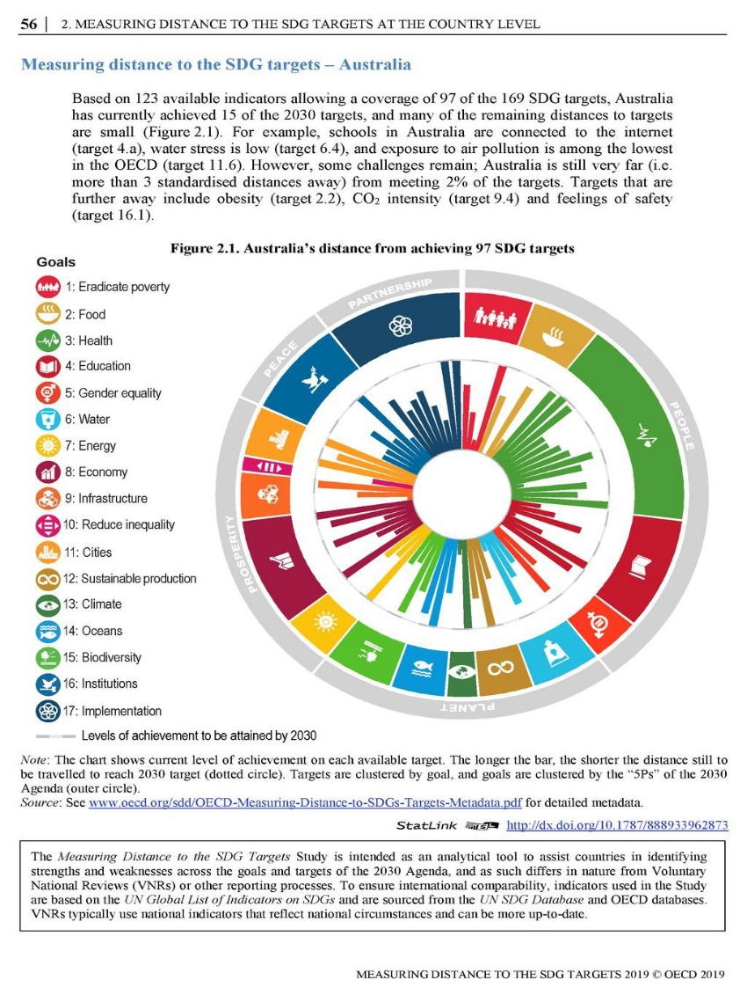
Figure 3 - Australia's progress towards achievement of the SDGs, 2019
Another global group has now taken their own interpretation of the SDGs, developing what they believe are the five critical environmental goals to be achieved by 2030. Called the Earthshot Prize and sponsored by the Duke and Duchess of Cambridge’s Royal Foundation, the group is focused on achieving significant outcomes relating to:
- Protect and restore nature
- Clean our air
- Revive our oceans
- Build a waste free world
- Fix our climate
Each year from 2021 to 2030, one individual or group from each category wins “£1 million in prize money [which] will support environmental and conservation projects that are agreed with the winners”
A number of individual organisations are now identifying which of the goals, particularly the SDG goals, are relevant to the work of that group and including the measurement of achievement of their sub-goals in their strategic plans, therefore making this work integral to the success of their organisation.

The structural changes in labour markets
Global labour markets are fairly chaotic at the moment. There are three main factors causing this: COVID-19; the introduction of new technologies and the structural changes caused by the rise in casualisation.
According to the Commonwealth Government, “There were just over 2.6 million casual workers employed in Australia in August 2019 who accounted for 24.4 per cent of all employees. Retail trade and Accommodation and food services account for a large proportion of all casual workers across Australia. Large numbers of casual workers are also employed in social assistance services, construction, health, education, road transport and other service industries. The predominant occupations for casual workers are sales assistants and salespersons, hospitality workers, carers and aides, sales support workers and food preparation assistants.”

What is the gig economy?
Also termed the ‘collaborative economy’, the ‘sharing economy’ or the ‘on-demand economy’, the ‘gig economy’ describes the rise of non-traditional ways of working and providing goods and services that involve temporary, task-by-task, and usually precarious, forms of employment. Gig forms of employment are not necessarily new – for example, freelancing, or consulting, has been the predominant mode of employment in several industries for a long time - but the emergence of digital talent platforms, such as Airtasker and Deliveroo, has seen the creation of new markets and recruitment platforms.
Research by the Grattan Institute states that approximately 30% of Australian workers are operating in non-traditional types of work. They believe that “[t]he rise of the sharing [or gig] economy can save Australians more than $500 million on taxi bills, help them to put underused property and other assets to work, and increase employment and income for people on the fringe of the job market.” When considering the growth of on-line platforms such as Airtasker, the Grattan Institute research finds that “Under today’s regulations, most platform workers are likely to be classified as independent contractors. They have more flexibility than employees do but may lack many protections that employees enjoy.”

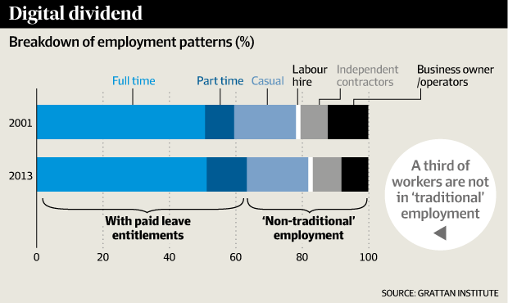
Figure 4 - Breakdown of employment patterns, Grattan Institute
According to some employer groups, the rise of the gig economy is being driven by workers who are expressing an increasing demand for autonomous and flexible work. Research by the McKinsey Global Institute adds more detail to this picture, suggesting there are four key segments of ‘independent’ workers: free agents, who actively choose independent work and derive their primary income from it; casual earners, who use independent work for supplemental income and do so by choice; reluctants, who make their primary living from independent work but would prefer traditional jobs; and the financially strapped, who do supplemental independent work out of necessity (McKinsey Global Institute 2016).

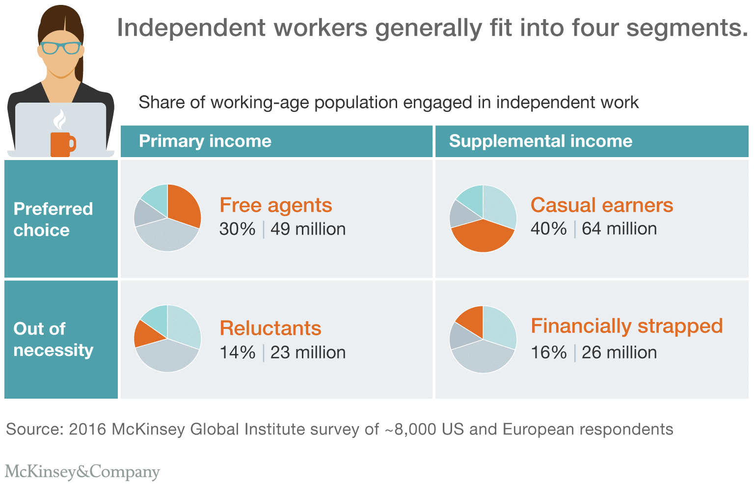
Is the gig economy a new phenomenon, or simply an extension of existing dynamics of labour market change such as casualisation? A number of commentators observe that, despite all the attention that the ‘gig economy’ has received, there is little that is actually new about these working arrangements. Hannah Reed, a senior policy officer for employment rights at the Trades Union Congress in the UK, contends that ‘these casual working terms are an extension of old practices, just accelerated by technology’.
At this point in time, the topic of the gig economy appears to open up as many questions as it does answers. How are gig workers to be classified for legal purposes – as ‘independent contractors’, ‘workers’ or ‘employees’? What rights do gig workers have to things like the minimum wage, unfair dismissal protections, holiday and sick pay, superannuation? What forms of redress or support should workers have when they feel they’re being exploited? These are just a selection of the issues currently preoccupying policymakers, industry, unions, and various courts of law and regulators, among other stakeholders.
Like other parts of the world, Australian labour markets are also undergoing structural change due to new technologies and the decline in full-time work, as well as dealing with the loss of local businesses and jobs as a result of the pandemic. If Regions are to ensure they have a robust labour market which is accessible to all, then it is important to gain a deeper understanding of the new economy and its impact on jobs. This includes the rise of the “gig” economy.
The gig economy is not something that can be fought against, it is a shift in an enormous economic machine beyond the power of most to affect. For an individual, the strategy of adapting, growing, and engaging can help overcome many of the hurdles inherent in gig work. With a bit of improvement, it may even lead to a more fulfilling concept of work.
If we are to help our communities to prepare for this different type of working, then there are three things which we need to help them develop. These are:
- Tenacity and adaptability - Always being open to new opportunities and being willing to try out new things leads to interesting and unique employment opportunities. Having a growth mindset and taking on challenges whenever they arise helps keep things fresh and interesting. Not being overly bothered by setbacks and taking failure in stride keeps you moving forward to the next opportunity and helps avoid stagnation.
- Social intelligence - The ability to connect with others, maintain a network, and deal with burning bridges is a primary avenue to securing work. In the Gig economy, reputation and personal brand are what land jobs and lead to repeat employment.
- A commitment to lifelong learning - The Gig economy requires either a wide diversity of skill or a high level of specialisation to secure regular gigs. Having a basic functional education and relying on labour as a primary saleable skill is coming to an end. Continuous improvement will have to become the norm to remain competitive, adapt to changing markets, and to take full advantage of opportunities as they arise.

Industry 4.0

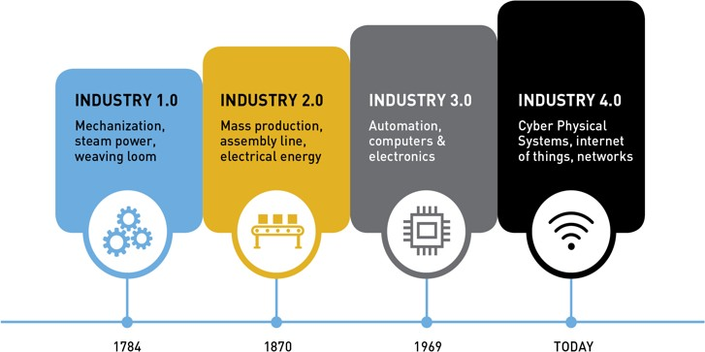
“The world is also seeing the emergence of Industry 4.0, the world’s 4th industrial revolution, and the rapidly changing nature of work and learning.
Many industries have, over the past decade, faced, or are facing, major structural adjustment, with the adoption of new intuitive technologies reshaping the workforce.

“Industry 4.0 is embedding smart, connected technology to transform economies, jobs and societies. Physical and digital technologies are combining through ‘analytics, artificial intelligence,

cognitive technologies, and the Internet of Things (IoT) to create digital enterprises that are both interconnected and capable of more informed decision-making’”.
With the closure of many large employers, regional labour markets are often now comprised of up to 90% of micro- to small businesses,
Figure 5 - Industrial revolutions and many small to medium enterprises (SMEs)
are less invested in upgrading to new technologies. This may be because those technologies are not really relevant to the business, the cost, the owner’s own fear of using technology, or the lack of necessary infrastructure to support the technology, e.g. availability of broadband.

As a result, those businesses may have chosen to retain their existing structures and staff. However, the advent of the pandemic has thrown that attitude into chaos and many local organisations have been thrust into having to use technologies such as on-line meeting and retail platforms in order to survive. If the Regional Skills Strategy is to be successful, then it must factor in the changing nature of work itself and how best to support local businesses to prepare themselves and their staff for the future.

The Reskilling Revolution
The World Economic Forum (WEF) is well aware of Industry 4.0 and its potential impact on labour markets around the world; and they have produced a variety of research papers and reports on the future of work. They also created a new department within the WEF called the Reskilling Revolution where they are partnering with countries around the world to identify the capabilities needed in the new world of work, and developing cooperative strategies to help workers gain those capabilities. They have also produced a 2020 report called The Jobs of Tomorrow which presents the results of their global research into what the new world of work may look like.

Figure 6 - WEF Industry 4.0 strategic intelligence map
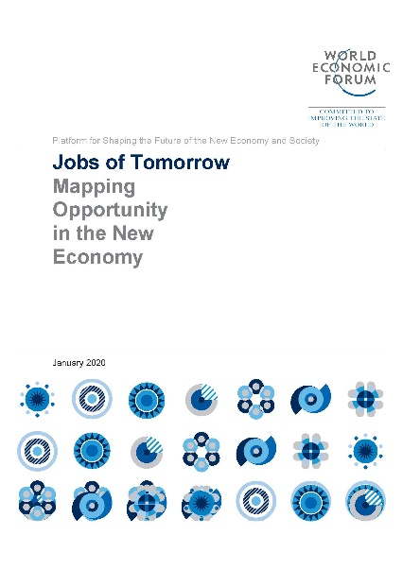
This initial research, which was released in January 2020, indicated that, by 2030, approximately one billion people globally will need to be reskilled for the jobs of the future. In the press release, the WEF defines the project as “an initiative to provide one billion people with better education, skills and jobs by 2030. The scheme aims to future-proof workers from technological change and help economies by providing new skills for the Fourth Industrial Revolution”
In their global conference, the Jobs Reset Summit, the WEF found that:
- “50% of all employees will need reskilling by 2025, as adoption of technology increases, according to the World Economic Forum's Future of Jobs Report.
- Critical thinking and problem-solving top the list of skills employers believe will grow in prominence in the next five years.
- Newly emerging this year are skills in self-management such as active learning, resilience, stress tolerance and flexibility.
- Respondents to the Future of Jobs Survey estimate that around 40% of workers will require reskilling of six months or less.
- Half of us will need to reskill in the next five years, as the "double-disruption" of the economic impacts of the pandemic and increasing automation transforming jobs takes hold.
That's according to the third edition of the World Economic Forum's Future of Jobs Report, which maps the jobs and skills of the future, tracking the pace of change and direction of travel. But the very technological disruption that is transforming jobs can also provide the key to creating them – and help us learn new skills.”
Technological change, industry transitions and globalization are impacting jobs and the skills required within those jobs. The OECD estimates that 1.1 billion jobs are liable to be radically transformed by technology in the next decade. The World Economic Forum predicts an overall net positive between job growth and decline but also finds that skills instability with all jobs will mean that nearly half of core skills are set to change by 2022 alone. Additionally, if current trends continue, the outdated content of education will further exacerbate the skills mismatch in the future. However, with increased predictive power, it has also become easier and faster to understand the in-demand skills and jobs of tomorrow and plan human capital development accordingly.
https://www.weforum.org/press/2020/01/the-reskilling-revolution-better-skills-better-jobs-better-education-for-a-billion-people-by-2030/

The OECD and the WEF highlight the potential for disruptive change to business models in coming years. The OECD estimates that robotics and artificial intelligence will replace 57% of jobs across its member countries. The WEF and OECD recognise, however, that rather than completely destroying jobs “automation redefines them in ways that reduce costs and boosts demand for workers in related occupations and/or industries”.

Whilst there is a reconfiguring and re-ordering of jobs, we are seeing traditional entry level, low skilled and repetitive jobs diminish, and short term, contract and casual work arrangements increase. This is particularly problematic for young people as those traditional entry level jobs are the ones in hospitality and retail which is where most young people get their start in the labour market.

The impact of new technologies

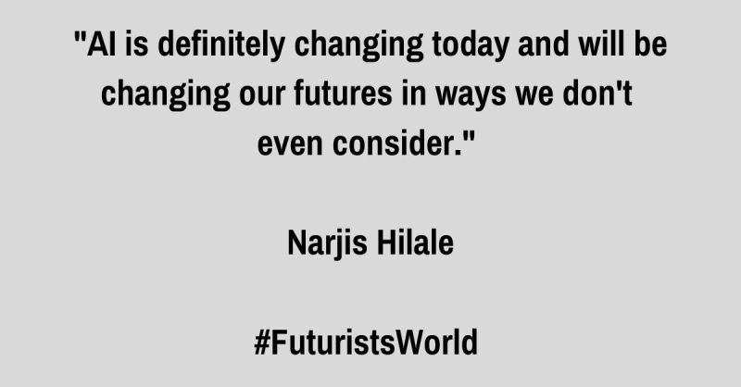
Figure 7 - From a post on LinkedIn
The impact of new technologies on specific occupations and industries is difficult to measure. The original research undertaken in 2017 by Frey and Osborne from Oxford University, used an algorithm which would measure the likelihood of a particular occupation being affected by new technologies. They tested their algorithm on the United States labour market where they applied it to 702 specific occupations and their conclusion was that 47% of jobs in the American labour market were highly susceptible to new technology (see the appendix to the working paper in footnote 30, which lists the occupations in order of vulnerability – low to high). That work was then extrapolated in the U.K., parts of Europe and the Australian labour market where the Committee for Economic Development of Australia (CEDA) estimated that 40%, or 5 million jobs, were at high risk due to automation. The skills which are thought to be ‘safe’ from automation in the medium term are fine motor skills and manipulation; creative intelligence; and social intelligence
The methodology developed by Frey and Osborne has been criticised as being too rigid and organisations like the OECD and the Regional Australia Institute (RAI) have modified the methodology to reduce the impact. Readers can use the interactive tool created by the RAI to identify the percentages of jobs in their regions which are at low, medium or high risk and to see which three occupations which employ the most people in that region are at high risk from automation and which three occupations which employ the most people in that region are at low risk from automation.
Figure 8 – Glen Eira data for jobs vulnerability 1 – RAI

Figure 9 – Glen Eira data for jobs vulnerability 2 – RAI
The two pictures above show the job vulnerability data for Glen Eira in Melbourne. Those involved in developing Regional Capability Strategies should also identify the jobs vulnerability for any other areas within their Region so that the strategies developed by the various organisations involved take account of the different labour markets in the overall region.

The future of work

Various research groups have made forecasts about the types of jobs which will be less available and those which are estimated to grow. The picture below shows the estimates which have been developed by the World Economic Forum as part of their Reskilling Revolution work. As can be seen, nine of the ten growth jobs are in the digital sector, while many of those which may decrease are process jobs of various types.

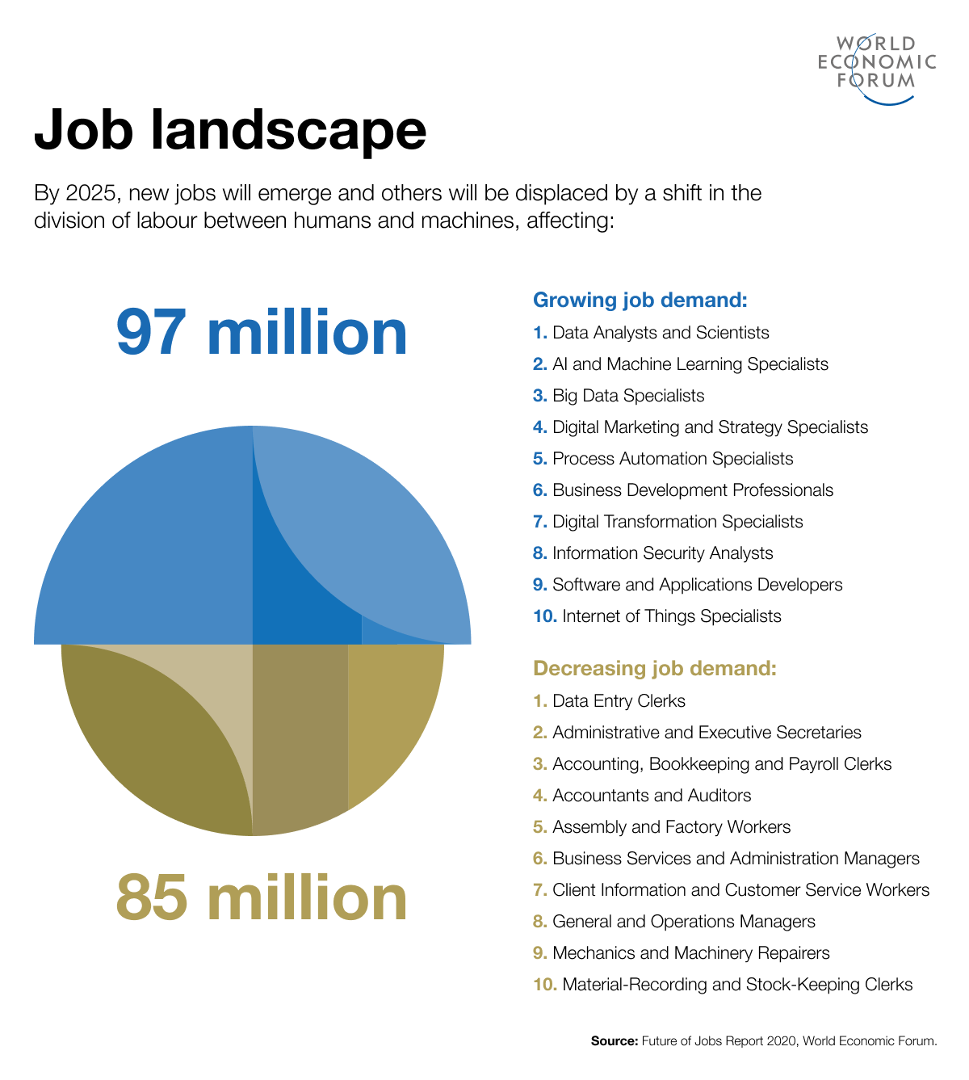
Figure 10 - WEF estimates of occupations which are likely to grow and those likely to decrease

In its 2020 Jobs of Tomorrow report discussed earlier in this discussion paper, the WEF also identified what the jobs landscape might look like as new economies are created around the world and found that:
“There are seven emerging professional clusters and 96 jobs of the future. … Growth in these clusters and jobs is largest among care roles and smallest among green professions. … In the aggregate, over the coming three years 37% of projected job opportunities in emerging professions will be in the Care Economy; 17% in Sales, Marketing and Content; 16% in Data and AI; 12% in engineering and Cloud Computing; and 8% in People and Culture. Current projections for Green professions remain low, with 117,200 openings (1.9%) projected for the period spanning 2020–2022.”

LinkedIn is another organisation attempting to identify emerging jobs and has used data from its own members to produce a national report. According to LinkedIn, “All of Australia's top five emerging jobs feature automation or Artificial Intelligence (Al) skills. Emerging jobs, like Al specialist, marketing automation specialist, robotics engineer and automation consultant, show how pervasive this trend is. Al is spreading to all organisational areas, from IT to finance and marketing. Al may not be deeply integrated into everything yet, but the trajectory is becoming clear.” This is even true with regard to interpersonal skills: “The rise of emerging jobs, like marketing automation specialist, site reliability engineer, service designer and customer success manager, all reflect the different ways in which companies are making sure the customers are coming first.”
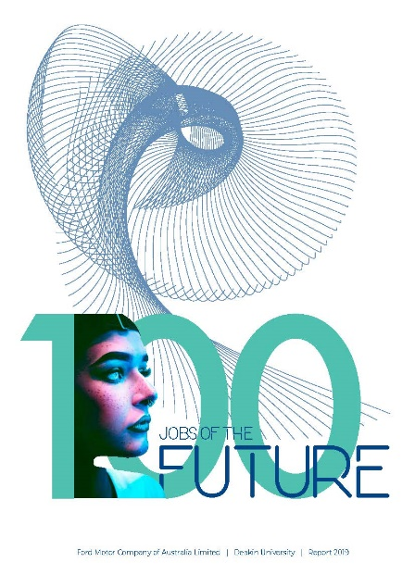
Whilst many organisations have produced future jobs’ reports, the final report which will be featured in this section has been created by Deakin University with funding from the Ford Motor Company.
According to the authors, “Writing on work futures is generally in agreement about the major drivers of change, including technological change — artificial intelligence, robots and big data, as well as innovation in materials, propulsion and energy strategies, climate change, globalization, population pressures and changed demographic profiles. The implications for jobs are more vague and futurists spread along a continuum stretching from predictions of dystopian futures to optimistic predictions of a better life for all.”
In undertaking this project, the researchers have conducted a review of the relevant literature as well as interviewing a range of people who are experts in their fields and seeking their views on what the future of work will be. From this material, they have distilled their findings into the types of capabilities that future workers are likely to need and developed a list of one hundred jobs which may provide future employment. The report states that “Some of the 100 jobs of the future are variations of those that already exist, possibly with more technology enablement that delivers instantaneous outcomes [such as a personal brand manager or a data privacy strategist]. … In contrast, a future nostalgist that recreates remembered experiences for the elderly, or a 100 year counsellor, who enables centurions to enjoy a ‘third age’, are new jobs that will emerge as medical advances keep extending human life.”
Finally, the researchers created eleven clusters of these new jobs, including:
- Technology,
- People,
- Law,
- Business,
- Environment,
- Urban,
- Agriculture,
- Health,
- Data,
- Experience and
- Space, based on “the major drivers of change: technological advances, climate change, data, democratisation, globalization, population pressures and changed demographic profiles”.
Whilst all of these reports, and many more, produce different lists of potential new jobs, there is a reasonably consistent theme that new jobs will mainly be in the technology and personal service sectors. This is quite a change from several years ago when only technology related jobs were considered likely with machines predicted to take over many of those people related occupations.

Education 4.0

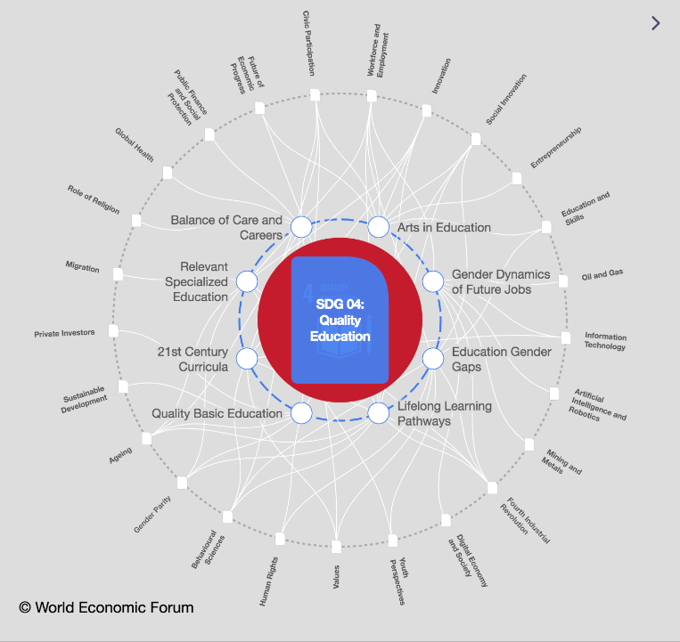
The United Nations Sustainable Development Goals (SDGs) discussed earlier in this document have identified the need for quality education systems around the world (SDG 4) and many countries and organisations are working towards this goal. However, the solution offered is often to develop alternative education settings and systems rather than conducting a holistic review of existing systems.

As a result, time and again, potential solutions are simply ‘tacked on’ to education landscapes at all levels, resulting in highly complex, overly difficult systems, particularly in State Government schools where State Education departments hold the power to change or add to curricula, and at university and VET levels Figure 11 - WEF Quality Education Strategic Intelligence map
funded by the Australian Government.

The situation is somewhat different in independent schools where principals and leadership teams may have the ability to vary curricula and pedagogical practices to better meet the needs and demographics of students.
In 2015, a study found that “a quarter of Australian school students are not finishing Year 12, and that completion rates are much worse in remote and economically disadvantaged communities.
Researchers at Melbourne's Mitchell Institute also warn Australia now has a less equitable education system than many other Western nations.” With the impact of the pandemic, this data is likely to be far worse for 2020-21.
It is very difficult for ordinary people to find accurate, current data on school attrition rates and this makes it problematic to build a reliable case for the changes needed to the education system. However, as communities, we should be concerned about the anecdotal feedback we hear about disengagement levels of young people and further investigation needs to occur on this subject.
A recent research project undertaken by University of Melbourne examines the issue of young people who have not just disengaged from education, but who have entirely detached from the entire education system; and notes that “Conservative estimates are that at least 50 000 children and young people of school age have detached from any educational program or institution, across the country at any given time” (p. 8). We should all be horrified by this statistic as, once those young people have detached from the system, it is extremely difficult to find them again.

UNICEF has advocated for balancing hard skills such as reading, writing, and math with soft skills such as problem-solving and creativity; in addition, instruction should no longer necessarily take place through front-of-class teaching, according to recent research. Pedagogy is a field ripe for innovation, especially when it comes to personalized learning. However, research has also highlighted that new learning tools do not always enable engagement with hard-to-reach groups - and it is critical that the drive for related innovation is matched by the monitoring of its effectiveness. Funding should be strategically allocated to trials, and any successes can be scaled up in the future. Greater public-private collaboration aimed at expanding this opportunity could also be beneficial - since governments cannot necessarily directly influence every classroom, they should instead focus on setting the right conditions for future-proof curricula and more innovative formats. As the education sector is both highly sensitive to change and a central pillar in the economy, better data collection could help ensure effectiveness
Education and Skills Dynamic Briefing, 2021, Strategic Intelligence, WEF https://intelligence.weforum.org/topics/a1Gb0000000LPFfEAO?tab=publications (need to be a member to access)

Whilst there are many pockets of innovation in education/training organisations, in the main the education sector still works on a traditional nineteenth century factory model, in which students proceed in lock-step fashion. In many schools and subjects, teachers may still use a convergent method of teaching which is usually “the default option in classrooms and is taught in interactions between teachers and students”. In using these convergent methods, teachers accustom students to seek the “one right answer”. This method of teaching makes it difficult for students to learn critical or creative thinking, but rather to accept that there is always a correct process to be followed to find that “one right answer”. Bonnardel and Didier identify the difficulty in teaching creativity when convergent teaching practices are used.
This is also reflected in the fact that the Torrance Tests, which are the most widely used and validated tests of creativity, including the use of divergent thinking, and are used in “testing environment from the level of kindergarten through adulthood, [provide data on] … creative achievement better than other measures of creative or divergent thinking, … [and are] utilized extensively in both the educational field and the corporate world” have been seeing a reduction in results. This is particularly concerning as creativity is now being identified as a critical capability for the jobs of the future.
“To reverse decline in creative thinking, [we] should reclaim opportunities for … students and teachers to think flexibly, critically, and creatively. Standardization should be resisted. Novel creative thought and expression should be encouraged, and opportunities should be made available for participation in active, critical discussion. Older children still need time for reflective abstraction, and they also need their parents and teachers to pay attention to them and support their creative endeavors.”
In many education/training organisations, a curriculum or competency driven approach also now appears to be more important than meeting the specific needs of learners. It often appears as if the entire teaching process is subsumed into the need to develop timetables and to program the delivery of siloed subjects or competencies. The problems in taking a curriculum driven approach have been the subject of research in a range of settings in which “such curriculum-driven structure may limit the development of problem representations that incorporate the necessary complexity and context to support adequate … solution development”. The difficulties in using a curriculum driven approach to problem-based learning is also examined in the context of medical training with the conclusion that a more integrated approach is needed for effective problem-based learning to occur. This is ironic given that critical thinking is another of the key capabilities identified as essential for the future of work. With the complexity of preparing people for the emerging labour market and the life decisions that this entails, this would seem to indicate that a different approach is needed by the education/training system.

Aristotle’s three types of learning
If we are to consider what different approaches may be useful in assisting people to gain the capabilities that they are likely to need in the changing labour market, then an examination of Aristotle’s three types of learning may be useful.
Aristotle (384-322BC) “allows for reconsidering and reintegrating ways of knowing: ‘traditional, practical, tacit, emotional, experiential, intuitive, etc., marginalised and considered insufficient by modernist [and postmodernist] thinking’”.
The three famous virtues defined by Aristotle are:
- episteme – scientific knowledge or theory, which is “universal, invariable, and context independent”. This is the type of knowledge which is highly valued and taught in both the Victorian Certificate of Education (VCE), as well as in higher education institutions such as universities.
- techne – “denotes production, namely art, workmanship, or skill (the ‘know how’). It describes the endeavor of using technical rationality to produce a certain outcome”. This is the type of knowledge which is taught in the current Victorian Certificate of Applied Learning (VCAL) as well as in competency based Vocational Education & Training (VET) institutions.
- phronesis – “is most often translated as ‘practical wisdom’ or prudence and denotes the ability or character trait of being able to use one’s collective knowledge in a different way to produce the most optimal outcome of a specific situation. A phronetic practitioner can draw on their knowledge, recognize what is needed in that situation, and deal with it effectively. This ability requires a high level of perception and flexibility, in combination with an understanding of which epistemic and technical knowledge to apply for the best outcome”.
It is this phronetic component which appears to be missing in the way people learn in our modern education and training institutions, as well as in modern workplaces. Whilst students are well prepared with theory and skill sets, they very often are not able to translate that learning effectively into their professional and private lives, and many appear to struggle to develop an ethical framework by which to guide their lives. Without these capabilities for ethical decision making, coupled with the reducing ability for many individuals to think creatively and critically, they are likely to be ill prepared to make effective decisions about the future. This is demonstrated by the willingness of so many to blindly believe anything they see or read on social media. Whilst this is indicative of all generations, it has been identified as a particular issue for the Generation Z group, born between 2005 and 2014, (Rickes 2016, 25), whose upbringing has been described as “oversimple, overslowed [and] overprotected”.

Neuroscience and neuroplasticity
If we accept that many existing mainstream education and training institutions are not adequately preparing students to deal with the complexities of the global labour market, then different forms of education need to be developed, and this means that different styles of teaching and learning may also be needed. In order to make informed decisions, regional stakeholders must develop a deeper understanding of learning – not just learning styles which have been used for decades, although often quite shallowly, but the biological workings of the brain and how it is used during the learning process and in the development of cognition. Neuroscience shows that “[t]he brain is a network of neural networks. Hence, some form of network theory is required to explain how learning and memory work”. One of the newer areas of research into teaching and learning is that of neuroplasticity, which is the study of how the brain forms new neural pathways, often after a traumatic event of some sort. For hundreds of years, scientists believed that humans brains were fully formed by adolescence and that no change was possible.
We have known for a long time that “practice makes perfect”; that is, the more often we repeat what we have learnt, the more sub-conscious, and automatic, that learning becomes. In neuroplastic terms, does this mean that we deepen those existing neural pathways which have been formed by the learning? In other words, “the more that you do something, the more it will ultimately form a more indelible relationship between neurons and neural networks”. Whilst this has been seen as a positive aspect of learning, does the other side of the neuroplastic coin mean that the deeper those neural pathways become, the less likely we are to form new neural pathways by learning alternative ways of doing that thing we have learnt, or of doing a new thing instead? Does this result in rigid thinking processes which have difficulty in accepting new information? This is known as cognitive dissonance, and the result is often the rejection of that new information.
If we are to successfully prepare individuals to make informed, sophisticated decisions about their futures, including future work, then we need to stop relying simply on traditional ways of helping them to learn, and be willing to examine new learning structures and use the latest scientific information on the brain and how it facilitates or impedes learning.
In developing a Regional Capabilities Strategy, education providers need to reconsider their curricula in VET programs and, at the moment, in VCAL to see if they have too much emphasis on vocational skills and not enough on assisting students to build the personal capabilities which will be essential no matter which industries and occupations in which they work. Also, if a Region is to successfully navigate the various factors impeding the local labour market, then it will be critical for all stakeholders to be involved in advocating to the Victorian and Australian Governments to sponsor, and participate in, a project in the region to truly review the current education system in order to bring it into line with the needs of the future.
Many Regions provide a discreet but significantly sized ‘laboratory’ where Governments can work with world class universities, TAFE colleges, as well as with community organisations such as the Region’s Local Learning and Employment Network and a range of large and small businesses. This would provide an opportunity to test out some of the innovative new educational ideas being proposed by global organisations such as the World Economic Forum (WEF) and the Organisation for Economic Cooperation and Development (OECD).

The Australian picture

The Australian Government is facing a number of major issues. When asked by the Lowy Institute in 2016 to identify the major issues facing the country and assess their level of importance, survey participants answered as follows:
Chart 1 - Major issues facing Australia, Lowy Institute, 2016
As this was well before the advent of COVID-19, participants saw education as a more important issue than health, whilst the economy only rated fourth. It will be interesting when the pandemic is finally able to be managed to see if the economy and education take their place as the most important issues facing the country. When asked for their views on the Coalition’s handling of the current major issues in 2021, respondents selected:
/
Chart 2 - Coalition 'report card' - Lowy Institute, 2021
As can be seen, there has been an improvement over the 2015 responses. However, even with this improvement, the highest rating, for managing the response to COVID-19, was still only accorded a 7.7 out of ten, with Australia’s response to climate change assessed as only 4.6.

COVID-19
For the Federal Government, the main issues relating to the pandemic have been:
- the enormous frustration felt by communities and State Governments with the major logistical problems which have dogged the vaccine roll-outs for many months,
- arguments with State Governments about the number and frequency of lockdowns and the impact on the ability of businesses to reopen,
- differences of opinion with State Governments about border closures and the impact of these particularly on tourism,
- decisions on when to reopen Australia to international visitors, and
- how to revitalise the Australian economy.

The chart below shows data on actual and projected spend by the Federal Government on the COVID-19 related programs. As can be seen, overall, from 2019-23 it is estimated that $140.85B will have been spent.
 | 2019-20 | 2020-21 | 2021-22 | 2022-23 | 2023-24
Economic response to COVID-19 ($ billion) | 55.2 | 82.5 | 2.9 | 0.25 | -
Proportion of GDP (%) | 2.8 | 4.2 | 0.14 | 0.0 | -
Proportion of total Australian Government expenditure (%) | 9.5 | 12.3 | 0.51 | 0.04 | -
Table 2 - Economic response to COVID-19

Unfortunately, many of the people hardest hit by the pandemic, i.e. those who work casually, were not actually eligible for supports such as Jobkeeper. “As shown in Insights into Industry and Occupation, when May data was released, the early impacts of COVID-19 were particularly evident in service based jobs, such as the Community and service workers and Sales workers occupations, and Arts and recreation services and Accommodation and food services industries. These are jobs often performed by casual workers.”
The corollary to this is that, now that parts of the country are reopening, many of those organisations, especially food services and hospitality are finding that many of their ex-workers are not interested in returning to those industries, but are attempting to find less precarious employment in other sectors.

Other issues affecting the Federal Government
Other issues which are likely to become more contentious as the pandemic slowly eases and the economy begins to recover again, include:
- climate change policy and action;
- growing opposition to the development of nuclear powered submarines as part of the AUKUS coalition;
- the increasing tension with China; and
- education and the economy.
Now is the time for Regions to establish research partnerships with the Federal and State Governments to ensure that the region is 'future proofed’ as best it can be, particularly in relation to ensuring that our local communities have access to quality and meaningful education and employment opportunities.

A Regional Picture

The author has used the G21 Region to illustrate how Regions might work to find the optimum way forward for their local communities.

The G21 Regional picture
The data provided here relates to the City of Greater Geelong. However, this does not mean that the labour markets of the other four municipalities which, together with Geelong, make up the G21 Region, are not also important. It has simply been done so that readers are not overwhelmed with data. As regional stakeholders become more sophisticated in their evidence-based practice, it will be crucial to consider the factors which affect the overall region, as well as those which are specific to each LGA.
There are a number of tools available to give us a snapshot of the local labour market. These include the Regional Australia Institute’s (RAI) Job Vulnerability Index (discussed earlier in this paper) which identifies the percentages of local occupations which have high, moderate or low vulnerability to automation. Overall, Geelong has 40.1% of jobs in the low vulnerability area (770,884 jobs); 31.8% of jobs in the moderate vulnerability area (610,524 jobs); and 28.1% of jobs in the high vulnerability area (540,524 jobs). Further research will need to be done into which occupations these are and how regional leaders can ensure that the people doing those jobs are well prepared to either transition into other areas of work or gain the extra skills which will be needed in their own jobs in the future.
This tool also identifies:
- The three occupations which employ the most people in the municipality and which are located in the low vulnerability area. For Geelong these are schoolteachers; midwifery and nursing professionals; and retail managers.
- The three occupations which employ the most people in the municipality and which are located in the high vulnerability area. For Geelong, these are sales assistants/ salespersons; hospitality workers; and food preparation assistants.
Two of the five G21 municipalities (Geelong and Surf Coast) together rate fifth highest in Australia with regard to job vacancy growth which has grown by 36%. Once again, further research will need to be undertaken to gain a deeper understanding of what this means – are those jobs a direct result of COVID-19 and does this mean they will disappear when the pandemic is under control; for example, will less health workers and less delivery drivers be required? Are these jobs in the high, moderate or low vulnerability area and what strategies do we need for each of these categories? Do we have sufficiently educated and trained residents to fill those vacancies and, if not, how do we address this?
At the moment, the Australian Bureau of Statistics (ABS) Census data is five years out of date. The first tranche of data from the 2021 Census is not due for release until mid-2022 and this is a problem as the Census gives us the most accurate, in-depth data on areas such as occupation of employment, industry of employment, highest level of education and highest level of post-secondary qualifications, as well as other major areas such as language spoken, need for assistance with regard to disability, targeted groups such as Aboriginal, refugee, gender, age, etc.
Regional stakeholders need to be able to develop a better understanding of the probable, possible and preferred futures for the region, with particular regard for the regional labour market, education and other factors which will impact on regional prosperity; and then to gather baseline data on each area so that appropriate and effective strategies and a strategic plan can be developed. These should build on the work already done in the region and identify which individuals, organisations or groups should lead each of those development areas.

What do we need to think about for the future?

There have been few times in history when the future of work has been less like the past. In the past people spent most of their time making things, however, in the future, relationships are likely to be as important as what is produced. In the past people worked in one job for most of their working lives, in the future a large section of the workforce will likely work for themselves. In the past people were defined by their job title; in the future they will be defined and redefined by the skills they have and how they go about marketing those skills. In the past, when you became something, you were known as that type of worker; in the future people are likely to go on becoming new versions of themselves as they continuously learn new skills. The jobs of the future look to be much more dynamic, interesting and rewarding. And today, for those who engage with this project of lifelong learning, that future is within reach.
Ford Motor Company and Deakin University, 2019. 100 Jobs of the Future, p. 23

What are the capabilities that will be important in the future?
In the past, when accredited training first came to prominence in the 1980’s and competencies began being used, the characteristics which were relevant to that competency were identified as knowledge/skills/attitudes and this was a really important way of distinguishing between innate personal attributes, the knowledge gained through learning and the skills mastered by practical application, all of which were equally important. Everything now appears to be bundled under the term ‘skills’ and this is most likely because the use of learning outcomes or competencies has encultured us to believe that we must be able to measure learning by the learner having to ‘do’ something. Since then, we have rarely overtly acknowledged the importance of all three components of learning, so perhaps it is time to reinvent the language we use and begin to describe the ‘capabilities’ which are needed rather than ‘skills’.
If the G21 Region is to truly attempt to build the capabilities of young people at school or university and those who are either in work or seeking work, then we must clearly identify those capabilities which will be critical in the future of work locally.
Various research groups have come up with different lists of skills/capabilities which will be needed in the future. These include the World Economic Forum’s list.
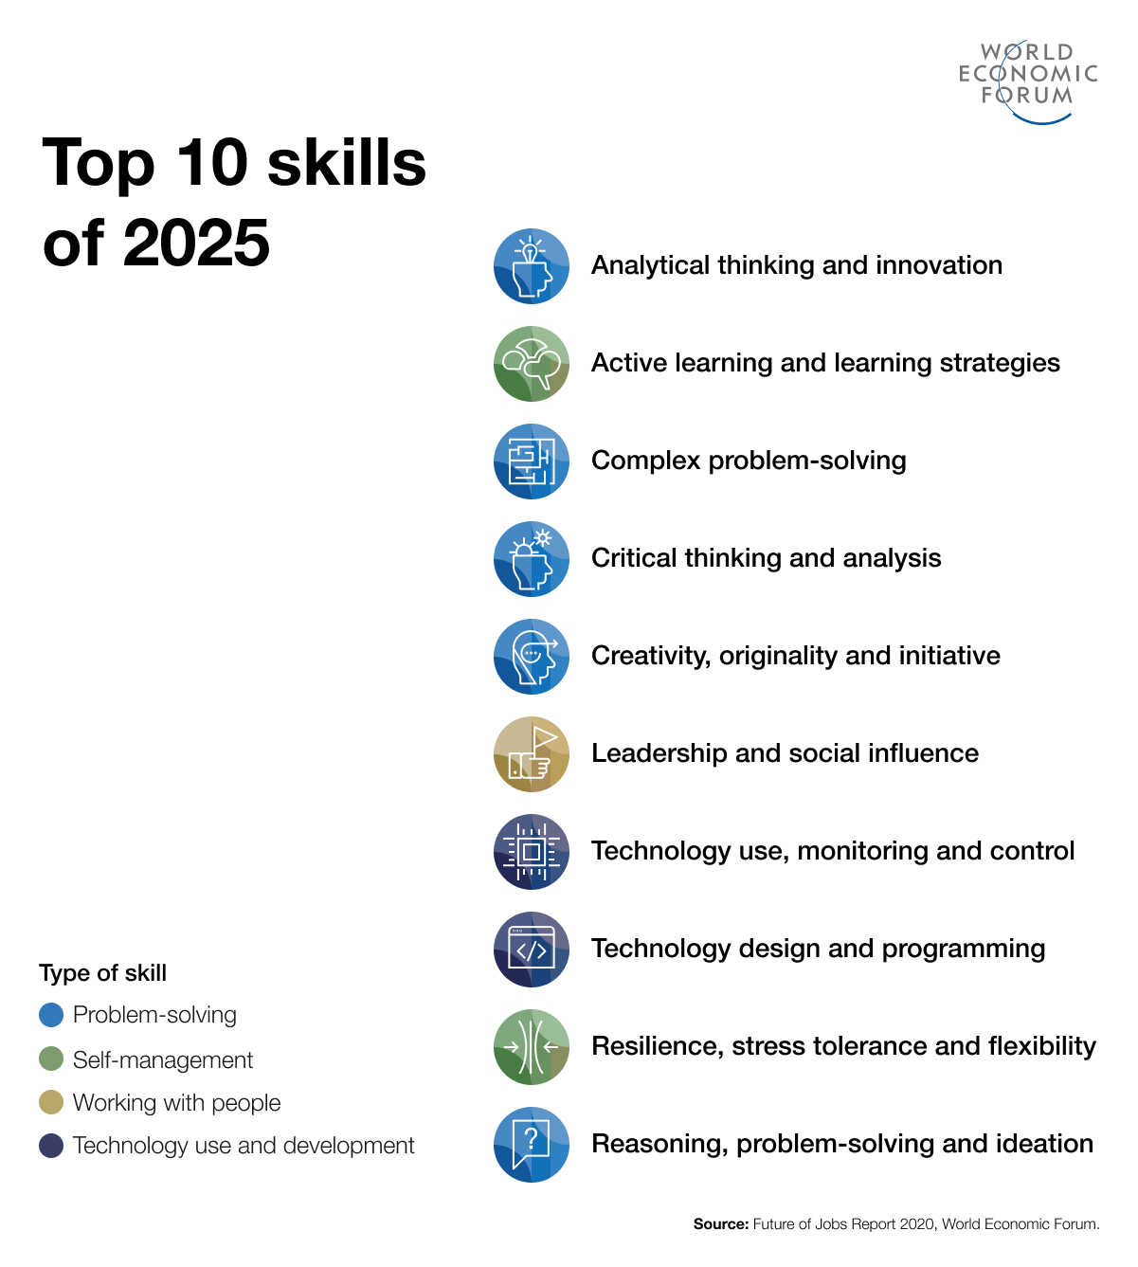
Figure 12 - WEF list of skills needed for the future of work

Deakin University’s research has identified three areas where learners will have to develop expertise. These are cross-disciplinarity – the ability to either build cross-disciplinary skills personally or to work in a cross-disciplinary team; interpersonal skills including communication with others, teamwork, etc. to enable work at the technology/human interface; and finally, other interpersonal skills such as “flexibility and adaptability in the face of change”.
The LinkedIn report mentioned earlier identifies the fifteen jobs which their data indicates are likely to grow and they list the skills which will be required for each.
The emphasis on creativity and design thinking is taken up in increasing interest in combining STEM education with arts and design, to provide the A in ‘STEAM’ education. Further, STEM is also linked to digital literacy: “The jobs of the future require problem solving and digital skills, and innovative and creative thinking, all taught through STEM” (Commonwealth Bank, 2017, p.11)

Finally, the Institute for the Future in Phoenix has identified a number of work skills for the future. These include:

Sense making - ability to determine deeper meanings

Social intelligence - ability to connect with others

Novel and adaptive thinking

Cross-cultural competency

Computational thinking – ability to translate data into abstract concepts and understand data-based reasoning

New-media literacy - ability to assess & develop content for new media forms and to use these for persuasive communication

The Cogitaire 5 Model

In 2017, Dr. Jude Walker was invited to present a paper at an international conference in Finland. The presentation set out her Cogitaire 5 Model of “thinking” capabilities.

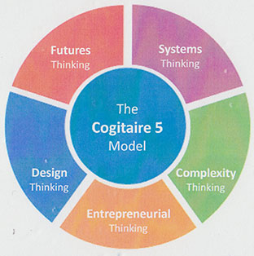
Figure 13 - The Cogitaire 5 Model

The Cogitaire 5 model is built around five “thinking” capabilities which the author believes could be useful in preparing people for the varied types of work and personal decisions which they need to make in the modern, chaotic world in which technology and its applications are growing exponentially and the structure of work itself is changing; as well as in dealing with complex organisational and personal issues. These capabilities include Futures Thinking, Systems Thinking, Complexity Thinking, Entrepreneurial Thinking and Design Thinking.
Work using this model should use the following structure:
- Futures thinking - Lewis Carroll has been quoted as saying “If you don’t know where you’re going, any road will get you there”. This is the reason that Futures Thinking is the first capability to be examined in the Cogitaire 5 model. Without having thought deeply about where the future may take us if we make no changes, and what possibilities may be realised if we have a process to work towards them, then we might as well simply “float along” and see where the road takes us.

Systems thinking - Having examined a range of possible futures and selected the preferred future, it is then necessary to gain a deeper understanding of the system within which the individual is situated. The specific system will depend on the nature of the issue which has prompted the investigation in the first place. If the desired future relates to an education/training/employment career-based future, then the system will be the one in which those sectors, as well as the individual’s own networks, are nested. If the issue is an organisational problem or opportunity, then the system may include suppliers, customers, etc. If a life decision is being made, then friends, family, social contacts, club membership, personal viewpoints, etc. will form the system. Until the system itself is understood, then it is not possible to identify where the drivers and barriers for change are located. Meadows defines a system as:
- a set of things – people, cells, molecules, or whatever – interconnected in such a way that they produce their own pattern of behaviour over time. The system may be buffeted, constricted, triggered, or driven by outside forces. But the system’s response to these forces is characteristic of itself, and that response is seldom simple in the real world.
- Complexity thinking - The problem with systems thinking is that, the minute we try to represent a system visually, we simplify it out of reality. Systems are highly complex things which “for their inner dynamic and emergent nature … have to deal with emerging, unexpected and unknown possibilities of interactions that may lead to conditions of complexity”. Chaos and ambiguity seem to be more prevalent today than previously, with the world being described as volatile, uncertain, complex and non-linear. This is why, having examined systems thinking, we must then consider complexity thinking in the development of the Cogitaire 5 model. The process of doing this can help the individual to develop their personal capabilities in change tolerance, problem solving, decision making and critical thinking.

- Entrepreneurial thinking - Amongst the many other quotes attributed to Albert Einstein, he has been reputed to have said “Insanity: doing the same thing over and over again and expecting different results” and “We can't solve problems by using the same kind of thinking we used when we created them”. Once the preferred future has been identified and the system, in all its complexity is understood, then the individual is ready to make the changes necessary to achieve their goals. This cannot be done in the mindset which has been used in the past – an entrepreneurial mindset will be required if new opportunities are to be identified and realised. Paul and Seward examine six qualities which have been identified as forming entrepreneurial thinking, “questioning, improvising, being open to risk, being ready to fail, working collectively, and being self-driven. These are qualities of a mind-set that helps individuals be innovative, creative, and resourceful in the way that they solve problems”. If the individual is to develop their personal capabilities for lateral thinking, risk tolerance, novel and adaptive thinking, as well as their curiosity, imagination and creative thinking capacity, then educators/trainers need to use exercises which will allow them to practice these skills.
- Design thinking - The final component of the Cogitaire 5 model is Design Thinking. Bringing an entrepreneurial mindset to the system in order to move towards the desired future, means that the user will need to redesign those parts of the system which are holding them back from making the necessary changes. Alternatively, if the system is completely dysfunctional, then they may need to attempt to design a completely new system which is supportive of the preferred future. Design thinking can be very useful as it “can be applied very generally in numerous fields, serving as a tool that systematically prevents its applicants from using traditional means of problem solving”. Vande Zande proposed that the use of design thinking can help individuals develop their critical thinking capabilities and it is these, along with creative thinking, which will be vital in achieving our desired future.
The model is designed to assist people to develop their overarching ability to think creatively and critically; and includes a range of tools and techniques which relate to each capability. The practice of these methods can also assist individuals to develop personal attributes which are vital if they are to be able to make informed, sophisticated decisions about their education and employment options, as well as the wide range of other important personal decisions which will affect their futures. There are many tools and techniques which relate to each of these thinking capabilities and the intent is that the selection of tools and techniques being taught is based on the particular needs of the learner or group of learners.
To test the efficacy of the model, the author consulted widely with employers, workers, educators, those seeking work, and the community agencies which work with all of these groups. As well, a workshop was conducted with the Board and staff of a not-for-profit working to improve education and employment outcomes for regional residents.
Considering this model as well as the various lists of skills/capabilities also discussed in this paper, what is consistent is the increasing importance of intra- and interpersonal capabilities rather than vocational skills; and education providers may need to spend more effort explicitly helping learners to build these capabilities rather than relying on industry specific VET programs.
If local residents are encouraged to transition to, or improve, their capabilities then the regional education/ training system will need to be fit for purpose to provide them with timely and relevant skills development using cutting edge educational systems and processes.

What can we do locally?

Chart 3 - Analysis of adult problem solving, adaptation skills and exposure to labour market disruptions, WEF
As can be seen from the chart above, Australia rates quite highly when it comes to adult problem solving and adaptation skills (highly rated for the future). However, to date, Australian labour markets have experienced fairly low disruption and, at the local level. This is changing as major factors such as COVID-19 impact our country as it has across the globe.
Taking account of these global forces, local regions will require a strategic plan and a blueprint for preparing the current and future labour force to take advantage of the new and changing jobs which we are likely to experience; and to further develop these and other capabilities which will be critical for their success.

Conclusion

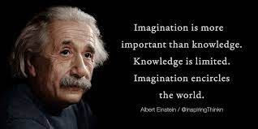

As Einstein reflected above, imagination is critical for true, meaningful change to be successful.

The intent of this Discussion Paper has been twofold; firstly to provide Regional leaders and stakeholders with knowledge about the global, national and regional labour markets and to provoke discourse about this information; and secondly, to engage other interested individuals and groups to bring their collective imagination together.
The Discussion Paper has included a number of suggestions for a way forward. Regional leaders and stakeholders now need to ensure that they have a comprehensive understanding of what labour markets are, how they operate, the influence they have on social, economic and health factors in local communities, and how best to identify and work towards a preferred future for the Region, with this work building on the various projects undertaken within and outside the region.

The outcome of this engagement should be to identify the regional values which will be vital if we are to survive and thrive in the new environment and to create an economic, political and social process to take the region into a prosperous and sustainable future which leaves nobody behind.

Regional Australia Institute, 2014, Talking Point: The Foundations of Regional Australia, http://www.regionalaustralia.org.au/wp-content/uploads/2014/12/Foundations-of-regional-Australia-FINAL-.pdf
Hutchens, G. 2021 Lift the minimum wage and employment still rises? How to anger the establishment and win a Nobel Prize, https://www.abc.net.au/news/2021-10-13/nobel-prize-in-economics-2021-david-card-minimum-wage/100531994?utm_campaign=abc_news_web&utm_content=facebook&utm_medium=content_shared&utm_source=abc_news_web&fbclid=IwAR2LERhEndT4Kqibxw6L5rY1Vgv_Ur4oZEGiZ-M0i4ZCYel27HrV-B-qzPU
Kirby, P. 1985. Review of labour market programs, AGPS, Canberra
Ross, R. & Whitfield, K. 2009. The Australian Labour Market, 3rd edition, Pearson Education, Australia, p. 1
ibid, p. 18
ibid
https://www.weforum.org/agenda/2019/10/how-we-can-end-short-termism-by-keeping-score/
Ross, R. & Whitfield, K. 2009. The Australian Labour Market, 3rd edition, Pearson Education, Australia, p.13
https://www.weforum.org/agenda/2019/10/how-we-can-end-short-termism-by-keeping-score/
https://read.oecd-ilibrary.org/development/measuring-distance-to-the-sdg-targets-2019_a8caf3fa-en#page58
Monash Sustainable Development Institute, Transforming Australia: SDG Progress Report, 2020 update, https://apo.org.au/sites/default/files/resource-files/2020-11/apo-nid309565.pdf
ibid, p. 3
ibid, p. 4
https://sdgs.org.au/
https://www.globalcitizen.org/en/
https://earthshotprize.org/
https://earthshotprize.org/awards/
Much of the material used in this section has been taken from an article by Walker, J., Noonan, M. and Gray, A. 2017, ‘The Gig Economy’ published in the 2017 Annual Report for the Geelong Region Local Learning & Employment Network
https://www.aph.gov.au/About_Parliament/Parliamentary_Departments/Parliamentary_Library/pubs/rp/rp1920/StatisticalSnapshotCasualWorkersAustralia
Minife, J 2016, ‘Peer-to-peer pressure: Policy for the sharing economy’, Grattan Institute, p. 35
https://grattan.edu.au/report/peer-to-peer/
ibid, p. 35
Australian Industry Group 2016, Thought Leader Paper: The Emergence of the Gig Economy, Australian Industry Group, p.5
Jacobs, E 2017, ‘The gig economy: freedom from a boss, or just a con?’, New Statesman, retrieved 28 March 2017 <http://www.newstatesman.com/politics/economy/2017/03/gig-economy-freedom-boss-or-just-con>.
O’Connor, B. & Walker, J. 2020, Geelong Region Local Learning & Employment Network (GRLLEN) Strategic Plan 2020 – 2024, p. 13
https://www.weforum.org/reports/jobs-of-tomorrow-mapping-opportunity-in-the-new-economy
https://www.weforum.org/press/2020/01/the-reskilling-revolution-better-skills-better-jobs-better-education-for-a-billion-people-by-2030/
ibid
https://www.weforum.org/agenda/2020/10/top-10-work-skills-of-tomorrow-how-long-it-takes-to-learn-them/
www2.deloitte.com, Industry 4.0 Are You Ready? 22nd January 2018, Accessed 17th March 2018
ibid
Frey, C. B 2017, The Future of employment: how susceptible are jobs to computerisation? https://enliza.es/SECCIONES_1/1_EL%20FUTURO%20DEL%20TRABAJO/RECURSOS/The_Future_of_Employment_OMS_Working_Paper.pdf
Durrant-Whyte, H., McCalman, L., O’Callaghan, S., Reid, A. and Steinberg, D. 2015, Australia’s future workforce, CEDA, https://cica.org.au/wp-content/uploads/Australias-future-workforce.pdf
op cit
http://www.regionalaustralia.org.au/home/regional-job-automation-pack/
https://www.weforum.org/reports/the-future-of-jobs-report-2020/in-full/infographics-e4e69e4de7
World Economic Forum, 2020, Jobs of Tomorrow: Mapping Opportunity in the New Economy, p. 4
https://business.linkedin.com/content/dam/me/business/en-us/talent-solutions/emerging-jobs-report/AUS-TOP-EMERGING-JOBS_compressedRevised.pdf
ibid, p. 2
ibid, p. 3
https://100jobsofthefuture.com/report/
ibid
ibid, p. 5
ibid
https://www.abc.net.au/news/2015-10-26/quarter-of-high-school-students-drop-out/6884578
Watterston, J. & O’Connell, M. 2019 Those Who Disappear: The Australian education problem nobody wants to talk about, Melbourne Graduate School of Education, https://education.unimelb.edu.au/mgse-industry-reports/report-1-those-who-disappear
Gilham, C.M. & Tompkins, J. 2016, Inclusion reconceptualized: Pre-service teacher education and disability studies in education. Canadian Journal of Education, 39(4), 1-25
Bonnardel, N. & Didier, J. 2016, Enhancing creativity in the educational design context: An exploration of the effects of design project-oriented methods on students' evocation processes and creative output. Journal of Cognitive Education and Psychology, 15(1), 80-101, p. 86
https://www.sciencedirect.com/topics/psychology/torrance-test
Kyung Hee Kim (2011): The Creativity Crisis: The Decrease in Creative Thinking Scores on the Torrance Tests of Creative Thinking, Creativity Research Journal, 23:4, p. 287
ibid, p. 294
Merahn, Steven M.D. 2015, Knowledge representation and care planning for population health management. The Journal of Medical Practice Management: MPM, 31(2), 126-130, p. 126
Amoako-Sakyi, Daniel, & Amonoo-Kuofi, Harold (2015) Problem-based learning in resource-poor settings: Lessons from a medical school in ghana. BMC Medical Education, 15
Eikeland, O. 2012, Action research - applied research, intervention research, collaborative research, practitioner research, or praxis research? International Journal of Action Research, 8(1), pp. 20-21
Harper, C. & Maher, J. 2017, Investigating philosophies underpinning dietetic private practice. Behavioral Sciences, 7(1), p. 3.
Ermenc, K.S., Vujisic, N.Z., & Spasenovic, V. 2015, Theory, practice and competences in the study of pedagogy - views of ljubljana and belgrade university teachers. CEPS Journal : Center for Educational Policy Studies Journal, 5(2), p. 3
ibid
Chen, J. 2015, Virtue and the scientist: Using virtue ethics to examine science's ethical and moral challenges. Science and Engineering Ethics, 21(1), 75-94
Rickes, P.C. 2016, Generations in flux: How gen Z will continue to transform higher education space. Planning for Higher Education, 44(4), p. 25.
Strauss, Willliam & Howe, Neil (1997). The Fourth Turning: An American Prophecy. Broadway Books, New York, p. 299
Tryon, Warren W.(2016, Transtheoretic transdiagnostic psychotherapy. Journal of Psychotherapy Integrati*on, 26(3), p. 277
Gustafson, C. 2017, David Perlmutter, MD: The dynamic brain. Integrative Medicine, 16(2), p. 22
https://poll.lowyinstitute.org/charts/coalition-government-report-card
Australian Government, Budget Strategy and Outlook: Budget Paper No. 1: 2020–21, Statement 6: Expenses and Net Capital Investment, pp. 6-10, https://www.aph.gov.au/About_Parliament/Parliamentary_Departments/Parliamentary_Library/pubs/rp/BudgetReview202021/AustralianGovernmentExpenditure
https://www.abs.gov.au/articles/insights-casual-employment-occupation-and-industry
http://www.regionalaustralia.org.au/home/regional-job-automation-pack/
http://www.regionalaustralia.org.au/home/regional-jobs-continue-record-streak/
ibid
https://100jobsofthefuture.com/report/ p. 37
https://business.linkedin.com/content/dam/me/business/en-us/talent-solutions/emerging-jobs-report/AUS-TOP-EMERGING-JOBS_compressedRevised.pdf
Ford Motor Company and Deakin University, 2019. 100 Jobs of the Future, p. 18
Institute for the Future, Phoenix University, Future Work Skills for 2020
Carroll, Lewis (n.d.). BrainyQuote.com. Retrieved July 25, 2017, from BrainyQuote.com Web site: https://www.brainyquote.com/quotes/quotes/l/lewiscarro165865.html.
Meadows, Donella H. (2008). Thinking in systems: A primer, p. 2. Chelsea Green publishing.
Badinelli, Ralph, Barile, Sergio, Ng, Irene, Polese, Francesca, Saviano, Marialuisa, & Nauta, Primiano D. (2012). Viable service systems and decision making in service management. Journal of Service Management, 23(4), 498-526, p. 507. doi:http://dx.doi.org.ezproxy.slv.vic.gov.au/10.1108/09564231211260396
Davis, Heather (2015). Social complexity theory for sense seeking: Unearthing leadership mindsets for unknowable and uncertain times. Emergence : Complexity and Organization, 17(1), 14-1F,2F,3F,4F,5F,6F,7F,8F,9F,10F,11F,12F,13F,14F. Retrieved from http://ezproxy.slv.vic.gov.au/login?url=https://search-proquest-com.ezproxy.slv.vic.gov.au/docview/1674426301?accountid=13905
Einstein, Albert (c.1330). https://www.brainyquote.com/quotes/quotes/a/alberteins385842.html.
Paul, Kristina A., & Seward, Kristen K. (2016). Place-based investment model of talent development. Journal of Advanced Academics, 27(4), 311-342. doi:http://dx.doi.org.ezproxy.slv.vic.gov.au/10.1177/1932202X16669546
Fischer, Matthias (2015). Design it! solving sustainability problems by applying design thinking. Gaia, 24(3), 174-178, p. 174. Retrieved from http://ezproxy.slv.vic.gov.au/login?url=https://search-proquest-com.ezproxy.slv.vic.gov.au/docview/1722884738?accountid=13905
Vande Zande, Robin (2007). Design education as community outreach and interdisciplinary study. Learning Through the Arts Journal, 3(1). Retrieved from https://escholarshiporg/uc/item/4f37f63k#page-1
World Economic Forum, 2017, Accelerating Workforce Reskilling for the Fourth Industrial Revolution: An Agenda for Leaders to Shape the Future of Education, Gender and Work, p. 1

